Câu 1:

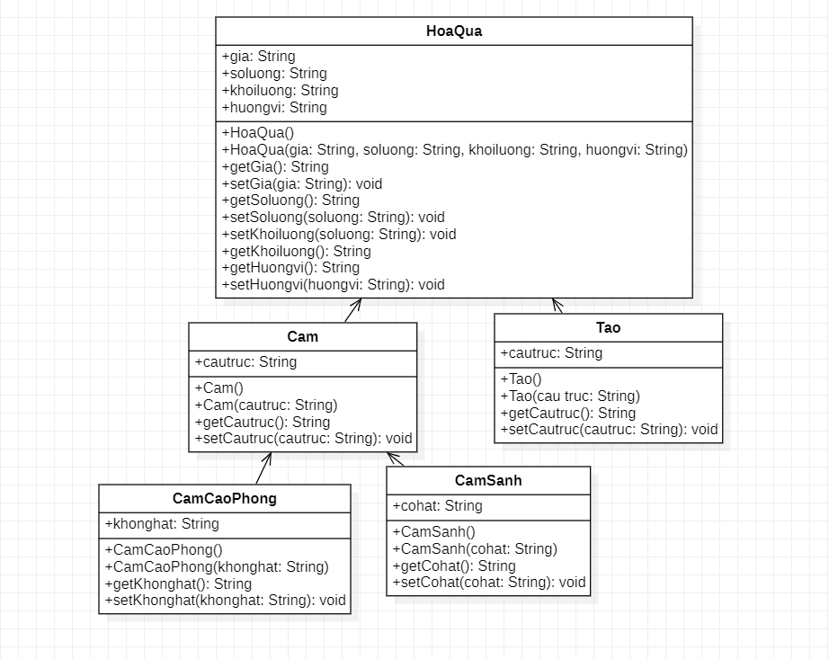

*Hoa quả:
package hoaqua;
public class HoaQua {
public String gia;
public String soluong;
public String khoiluong;
public String huongvi;
public HoaQua(){}
public HoaQua(String gia,String soluong,String khoiluong,String huongvi){
this.gia=gia;
this.soluong=soluong;
this.khoiluong=khoiluong;
this.huongvi=huongvi;
}

public String getGia() {
return gia;
}

public void setGia(String gia) {
this.gia = gia;
}

public String getSoluong() {
return soluong;
}

public void setSoluong(String soluong) {
this.soluong = soluong;
}

public String getKhoiluong() {
return khoiluong;
}

public void setKhoiluong(String khoiluong) {
this.khoiluong = khoiluong;
}

public String getHuongvi() {
return huongvi;
}

public void setHuongvi(String huongvi) {
this.huongvi = huongvi;
}
public class Cam extends HoaQua{

}
public static void main (String[] args){
Tao t = new Tao();
Cam c = new Cam();
}
}

*Cam:

import hoaqua.HoaQua;

public class Cam extends HoaQua{
public String cautruc;
public Cam(){}
public Cam(String cautruc){
this.cautruc=cautruc;
}
public String getCautruc() {
return cautruc;
}

public void setCautruc(String cautruc) {
this.cautruc = cautruc;
}
public class CamCaoPhong extends Cam{
public String khonghat;
public CamCaoPhong(){}
public CamCaoPhong(String khonghat){
this.khonghat=khonghat;
}
public String getKhonghat() {
return khonghat;
}

public void setKhonghat(String khonghat) {
this.khonghat = khonghat;
}
}
public class CamSanh extends Cam{
public String cohat;
public CamSanh(){}
public CamSanh(String cohat){
this.cohat=cohat;
}
public String getCohat() {
return cohat;
}

public void setCohatt(String cohat) {
this.cohat = cohat;
}
}
}

*Táo:

package hoaqua;
public class Tao extends HoaQua{
public String cautruc;
public Tao(){}
public Tao(String cautruc){
this.cautruc=cautruc;
}
public String getCautruc() {
return cautruc;
}

public void setCautruc(String cautruc) {
this.cautruc = cautruc;
}
}

Câu 3:

package shape;
public class Shape {
public String color="red";
public boolean filled=true;
public Shape(){}
public Shape( String color, boolean filled){
this.color=color;
this.filled=filled;
}

public String getColor() {
return color;
}

public void setColor(String color) {
this.color = color;
}

public boolean isFilled() {
return filled;
}

public void setFilled(boolean filled) {
this.filled = filled;
}

@Override
public String toString() {
return "Shape{" + "color=" + color + ", filled=" + filled + '}';
}
public class Circle extends Shape{
public double radius;
public double area;
public double perimeter;
public Circle(){}
public Circle(double radius){
this.radius=1.0;
}
public Circle(double radius, String color, boolean filled){

}

public double getRadius() {
return radius;
}

public void setRadius(double radius) {
this.radius = radius;
}
public double getArea(){
return area;
}
public double getPerimeter(){
return perimeter;
}

@Override
public String toString() {
return "Circle{" + "radius=" + radius + '}';
}
}
public class Rectangle extends Shape{
public double width=1.0;
public double length=1.0;
public double area;
public double perimeter;
public Rectangle (){}
public Rectangle (double width,double length ){
this.width=width;
this.length=length;
}
public Rectangle (double width,double length,String color, boolean filled ){
}

public double getWidth() {
return width;
}

public void setWidth(double width) {
this.width = width;
}

public double getLength() {
return length;
}

public void setLength(double length) {
this.length = length;
}
public double getArea() {
return area;
}
public double getPerimeter() {
return perimeter;
}

@Override
public String toString() {
return "Rectangle{" + "width=" + width + ", length=" + length + '}';
}
}
public static void main(String[] args){

}
}

